Group 2

Christopher Regan

Alex Gorinson

Garrett Partenza

Temi Owoeye

Thiri Hsu Myat Aung

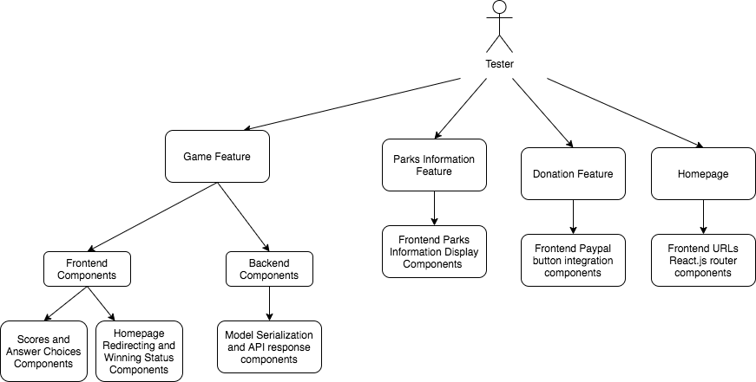

Integration Test Plan Diagram

# Integration Test Plan

To test the whole website as a software bundle including frontend and backend components, big bang integration testing methodology will be used to verify and validate the components are interactive as intended.

Procedures:

1. **Game feature** - the trivia game feature application is integrated into the website and it can be divided into backend Django and frontend React.js. To test the backend Django of the web application, the interaction and integration of model serialization of objects and API response components will be tested. To validate the game feature, the integration of scoring based on the choice of the user will be grouped together. The homepage redirection components during the game or after the game will be grouped together with the game status for integration testing.
2. **Parks information feature** - The frontend parks feature relies on the external API to retrieve the information of parks. Therefore, to verify the information feature about parks, the bundle of park information display components will be tested.
3. **Donation feature** - The donation feature also does not rely on the Django backend and thus, the interactive components of the Paypal payment method integration will be tested.
4. **Homepage -** According to React router DOM, homepage is the entry point of navigating to other features. Therefore, frontend URL routing and React.js router components will be verified together.